Recipe List

After choosing a recipe category the corresponding recipe list is displayed. Each recipe is displayed with the date on which is was added, its name, the category, and, if available, with the date of the last preparation as well as caloric information.

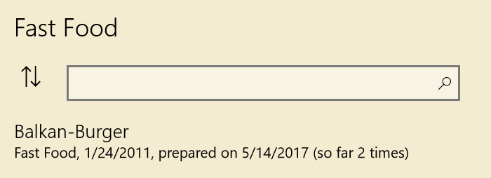

Depending on the screen or window size the selected recipe is displayed next to the list. At small sizes, the program navigates to the full-screen view after selecting a recipe.

By pressing the button next to the search box, you can change the sort order.

While you enter text in the search box the program suggests matching recipes. This search is based only on the recipe titles. If you want to search for specific terms in recipes, enter the search term, and press Enter. This will bring you to a list of all recipes that contain the search term. The search applies to the recipes of the current category only.

The navigation menu has the following options:

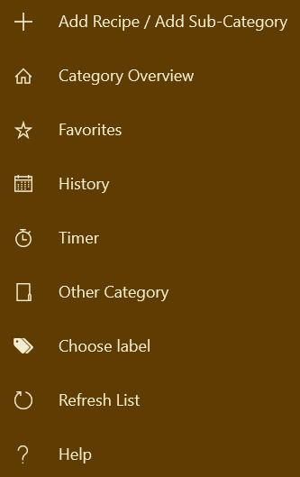

The function *Change Category* offers direct access to a different category without first changing to the overview page. Analogously, you can navigate to the recipes that are tagged with a certain label by selecting “Choose Label”.

## Caloric Information

The app scans all recipes in PDF format for caloric information (“xx kcal”). If found, the caloric information is displayed in the recipe list. The scan is performed once for each recipe as soon as it is displayed for the first time.

With the menu function “Scan recipes for caloric information” you can scan all recipes of the current category or of all categories for caloric information. This may take some time as the scan of each recipe can take several seconds. You can cancel the scan anytime. When continued, the scan resumes where it left off.

Moreover, you can enter the caloric information directly by choosing the menu item “Change caloric information”.

## Add a new recipe

There are three methods to add a new recipe.

### Adding via the file system

Suppose you receive a soup recipe as an email attachment. The easiest method to get an existing recipe in the collection is to copy it directly into the corresponding category folder. Suppose that you already have a category with name “Soups”. The program creates a folder under the startup folder for each category with the same name. For example, if your startup folder has the path "This PC > Documents > Recipes", then there is another folder: "This PC > Documents > Recipes > Soups", where all soups recipes are stored. So just open the attachment, select "Save as", and save the recipe in this folder. If you have already loaded the category in the app, choose the function *Reload Recipes*, so that you can see the recipe.

### Download a recipe from the Internet

When browsing the Internet you may find a recipe that you would like to add to your collection. In this case proceed as follows:

•       Copy the recipe name to the Clipboard.

•       Some recipe portals offer a function to directly download a recipe in PDF format. If this is possible, download the recipe and store it in the appropriate category folder. Use the clipboard to specify the recipe title as the file name.

•       If such a possibility is not given, you print the recipe. Most portals offer a printing function. Otherwise, you use the print function of your browser. Choose a PDF printer, like for example "Microsoft print to PDF" or CutePDF printer. If you are asked for the file name, use the clipboard and save the recipe in the provided recipe folder.

### Add an existing file

If the recipe to be added is already on your computer, choose the function *New Recipe*. In the subsequent menu you select *Add Existing File*. This opens a file selection window that allows you to choose the recipe (PDF or RTF).

### Enter a new recipe

You can directly enter a recipe via the integrated editor. Best you look before at the templates in the *Recipe Templates* folder. Note the name of the template that you want to use.

To enter a new recipe, select again the function of *New Recipe* and then *Enter New Recipe*. The following dialog appears:

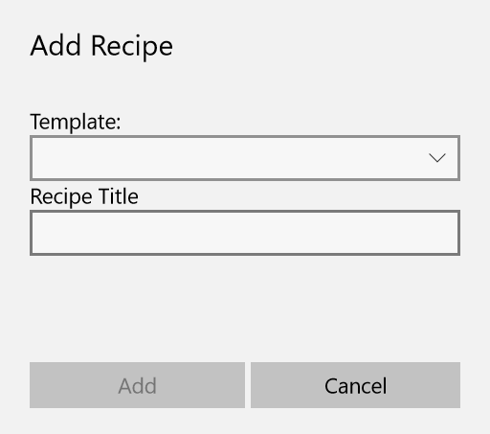

If you want, you can select a recipe template via the drop-down box. Providing a recipe title is mandatory. After pressing *Add* the title is copied to the Clipboard, so that you can use it directly as a title when entering the recipe text.

## Add a new sub-category

In each main category you can create further sub-categories. To do this, choose “+” and “New Sub-Category”:

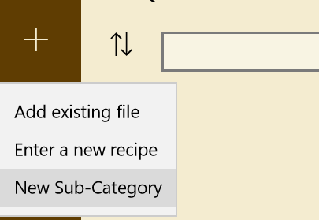

On the next dialog you enter the name of the new sub-category:

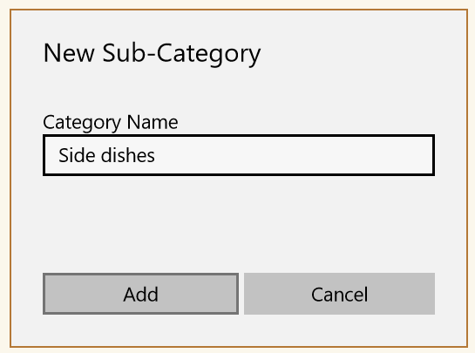

Afterwards, the new category is listed at the beginning of the recipe list.

## Editing sub-categories

Left to each sub-category you see three dots that open a menu for renaming and deleting sub-categories:

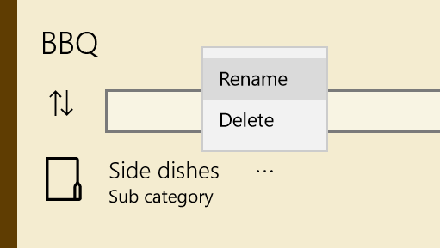

Note, that you can delete empty folders only.